

**Project Name**

RATINGS PREDICTION PROJECT REPORT

I would like to express my deep sense of gratitude to my SME (Subject Matter Expert) Ms **Swati Mahaseth** as well as **Flip Robo Technologies** who gave me the golden opportunity to do this data analysis project on **Ratings Prediction Project** , which also helped me in doing lots of research and I came to know about so many new things.

I have put in my all efforts while doing this project.

All the external resources that were used in creating this project are listed below:

1. https://www.google.com/
2. https://www.youtube.com/
3. https://github.com/
4. https://www.kaggle.com/
5. https://towardsdatascience.com/
6. https://www.analyticsvidhya.com/
7. https://www.nltk.org/data.html

# INTRODUCTION

* Business Problem Framing:

Websites and online stores increasingly rely on rating systems and interactive elements for visitors and customers: users leave ratings on websites or give their opinions on products and companies using the comment boxes embedded on the page. The added value for users is clear: Customers and website visitors often gain important information through ratings and can read other user’s experiences before investing in a product, service, or company. Since it’s not possible to take a closer look at products online, these ratings and reviews fill information gaps. Online shopping is convenient, practical, and fast, but nonetheless there’s a distance between the provider and the customer. However, if a website contains **ratings or a comment box**, this can help to close the distance between the provider and the customer: Customers can then use the feedback to help each other decide whether to go ahead with the purchase by providing information on the function, range, and value of a product.

The rise in E-commerce has brought a significant rise in the importance of customer reviews. There are hundreds of review sites online and massive amounts of reviews for every product. Customers have changed their way of shopping and according to a recent survey 70 percent of customers say that they use rating filters to filter out low rated items in their searches. The ability to successfully decide whether a review will be helpful to other customers and thus give the product more exposure is vital to companies that support these reviews like Google, Amazon, Flipkart, Myntra, Reliance etc. There are two main methods to approach this problem. The first one is based on review text content analysis and uses the principles of natural language processing (the NLP method). This method lacks the insights that can be drawn from the relationship between costumers and items. The second one is based on recommender systems specifically on collaborative filtering and focuses on the reviewer’s point of view.

* Conceptual Background of the Domain Problem:

Rating prediction is a well-known recommendation task aiming to predict a user’s rating for those items which were not rated yet by customers. Predictions are computed from users’ explicit feedback i.e., their ratings provided on some items in the past. Another type of feedback are user reviews provided on items which implicitly express users’ opinions on items. Recent studies indicate that opinions inferred from users’ reviews on items are strong predictors of user’s implicit feedback or even ratings and thus, should be utilized in computation. As far as we know, all the recent works on recommendation techniques utilizing opinions inferred from users’ reviews are either focused on the item recommendation task or use only the opinion information, completely leaving users’ ratings out of consideration. The approach proposed in this project is filling this gap, providing a simple, personalized and scalable rating prediction framework utilizing both ratings provided by users and opinions inferred from their reviews. Experimental results provided on dataset containing user ratings and reviews from the real-world Amazon and Flipkart Product Review Data show the effectiveness of the proposed framework.

* Review of Literature

What is rating?

Rating is a classification or ranking of someone or something based on a comparative assessment of their quality, standard or overall performance.

This project is more about exploration, feature engineering and classification that can be done on this data. Since we scrape huge amount of data that includes five stars rating, we can do better data exploration and derive some interesting features using the available columns.

We can categorize the ratings as: 1, 2, 3, 4 and 5 stars respectively.

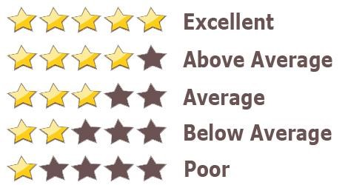

The goal of this project is to build an application which can predict the rating by seeing the review. In the long term, this would allow people to better explain and review their purchase with each other in this increasingly digital world.

• Motivation for the Problem Undertaken

This model will be used by the websites where reviews are available but not the corresponding rating(s). This will help in assigning particular rating(s) for the given reviews.

Every day we come across various products in our lives, on the digital medium we swipe across hundreds of product choices under one category. It will be tedious for the customer to make selection. Here comes 'reviews' where customers who have already got that product leave a rating after using them and brief their experience by giving reviews. As we know ratings can be easily sorted and judged whether a product is good or bad. But when it comes to sentence reviews, we need to read through every line to make sure the review conveys a positive or negative sense. In the era of artificial intelligence, things like that have got easy with the Natural Language Processing (NLP) technology. Therefore, it is important to minimize the number of false positives our model produces, to encourage all constructive conversation. Our model also provides beneficence for the platform hosts as it replaces the need to manually moderate discussions, saving time and resources. Employing a machine learning model to predict ratings promotes easier way to distinguish between products qualities, costs and many other features. Many product reviews are not accompanied by a scale rating system, consisting only of a textual evaluation. In this case, it becomes daunting and time-consuming to compare different products in order to eventually make a choice between them. Therefore, models able to predict the user rating from the text review are critically important. Getting an overall sense of a textual review could in turn improve consumer experience.

**Analytical Problem Framing** • Mathematical/ Analytical Modeling of the Problem

As per the client’s requirement for this rating prediction project I have scraped reviews and ratings from well-known e-commerce sites. This is then saved into CSV format file. I have shared the script for web scraping into the GitHub repository.

In our scrapped dataset our target variable column "Ratings" is a categorical variable i.e., it can be classified as 1, 2, 3, 4 and 5 stars. Therefore, we will be handling this modelling problem as a multiclass classification project.

Then loaded this data into a dataframe. For checking datatypes and null values pandas.DataFrame.info() method has been used. To change the column name pandas.DataFrame.rename() method has been used and to drop the null values pandas.DataFrame.dropna() method has been used. To replace and remove the certain terms and punctuations, pandas.Series.str.replace() method with regular expression has been used. To get rid of stop words, nltk.corpus.stopwords() method has been used. I have gone through several EDA steps to analyse the data. After all the necessary steps I have built an NLP ML model to predict the ratings.

* Data Sources and their formats

The project is being done in two parts:

* Data Collection Phase
* Model Building Phase

Data Collection Phase:

We have to scrape at least 20000 rows of data. We can scrape more data as well, it’s up to you. More the data better the model. In this section we need to scrape the reviews of different laptops, Phones, Headphones, smart watches, Professional Cameras, Printers, monitors, home theatre, router from different ecommerce websites.

Basically, we need these columns:

1. Reviews of the product.
2. Rating of the product.

Fetching an equal number of reviews for each rating, for example if we are fetching

10000 reviews then all ratings 1,2,3,4,5 should be 2000. It will balance our data set. Convert all the ratings to their round number as there are only 5 options for rating i.e., 1, 2, 3, 4, 5. If a rating is 4.5 convert it 5.

Model Building Phase:

After collecting the data, you need to build a machine learning model. Before model building do all data pre-processing steps involving NLP. Try different models with different hyper parameters and select the best model. We will need to follow the complete life cycle of data science that includes steps like -

1. Data Cleaning
2. Exploratory Data Analysis and Visualization
3. Data Pre-processing
4. Model Building
5. Model Evaluation
6. Selecting the best model

We collected the data from difference e-commerce websites like Amazon and Flipkart. The data is scrapped using Web scraping technique and the framework used is Selenium. I scrapped around 77550 records of the reviews data and saved it in a CSV format file.

**Importing Libraries**

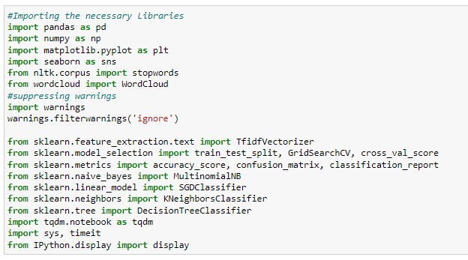

* Data Pre-processing Done:

The following pre-processing pipeline is required to be performed before building the classification model prediction:

* 1. Load dataset:

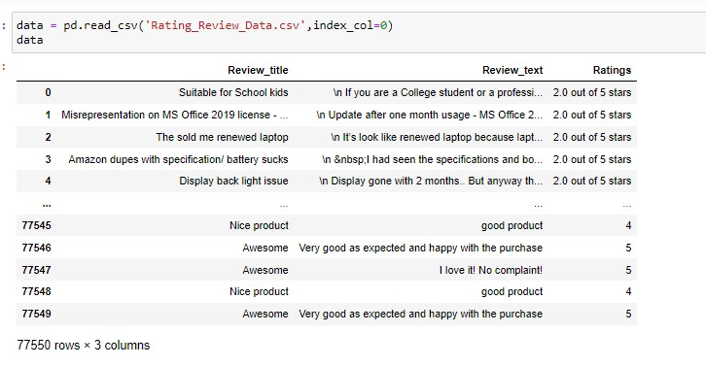

* 1. Merging feature Review_title and Review_text to review_text
  2. Dropping columns Review_title and Review_text.
  3. Treating Null Values by dropping null value rows using pandas dropna() method.
  4. Converting review_text to lower-case.
  5. Removing punctuations, leading whitespaces, trailing whitespaces and replace money symbols with 'dollars', numbers with 'numbr', white space between terms with single space.
  6. Removing Stop Words
  7. Converting Text into Vectors using TfidfVectorizer
  8. Building the predictive model.
  9. Loading the serialized Model
  10. Predicting Output by using the final model.

Checked the ratings column and it had 10 values instead of 5 so had to clean it through and ensure that our target label was updated as a numeric datatype instead of the object datatype value. Made sure that the string entries were replaced properly.

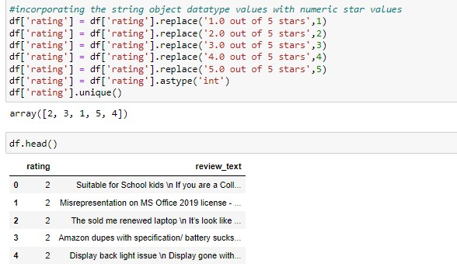

* Data Inputs- Logic- Output Relationships

|  |  |  |
| --- | --- | --- |
| Input | Logic (algorithm) | Output |
| Review_text (object) | MultinomialNB  SGDClassifier  KNeighborsClassifier  DecisionTreeClassifier | rating |

There is 1 input variable needs to be provided to the logic to get the output i.e. rating. Logic highlighted in green i.e. SGDClassifier is the best performing algorithm among all other logics on this dataset.

* State the set of assumptions (if any) related to the problem under consideration

By looking into the target variable/label, we assumed that it was a multiclass classification type of problem. Also, we observed that our dataset was imbalance so we will have to balance the dataset for better prediction accuracy outcome. The 5-star rating system allows respondents to rank their feedback on a 5-point scale from 1 to 5.

The more stars that are selected, the more positively your customer is responding to the purchased products. People tend to overlook businesses with a less than four star rating or lower. Usually, when people are researching a company, the goal is to find one with the highest overall score and best reviews. Having a five-star rating means a lot for your reputation score and acquiring new customers.

* Hardware and Software Requirements and Tools Used

 ➢ Hardware Used:

RAM: 8 GB

CPU: AMD A8 Quad Core 2.2 Ghz

GPU: AMD Redon R5 Graphics ➢ Software Tools used:

Programming language: Python 3.0

Distribution: Anaconda Navigator

Browser-based language shell: Jupyter Notebook ➢ Libraries/Packages Used:

* + Pandas
  + Numpy
  + Matplotlib
  + Seaborn
  + Scipy.stats
  + Sklearn
  + NLTK
  + wordcloud

## Model/s Development and Evaluation

* Identification of possible problem-solving approaches (methods)

We checked through the entire training dataset for any kind of missing values information

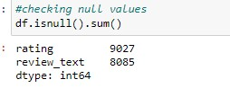

We dropped all the null values from our dataframe using the using pandas dropna() method.

Then we went ahead and took a look at the dataset information. Using the info method, we are able to inspect the datatype information. We have a total of 2 columns and both have object datatype.

Code:

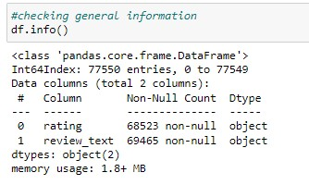

* Testing of Identified Approaches (Algorithms)

The list of all the algorithms used for the training and testing classification model are listed below:

1. MultinomialNB
2. SGDClassifier
3. KNeighborsClassifier
4. DecisionTreeClassifier

From all of these above models, SGDClassifier gave me good performance.

• Run and Evaluate selected models

To perform training and testing operation(s) following functions has been defined for which codes are as follows:

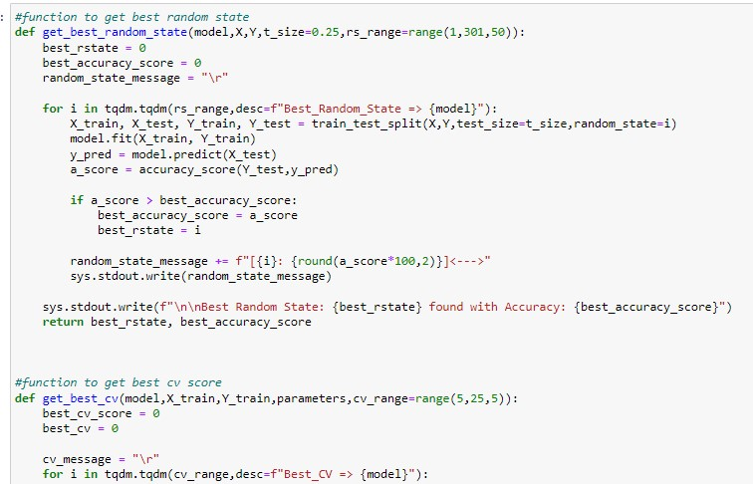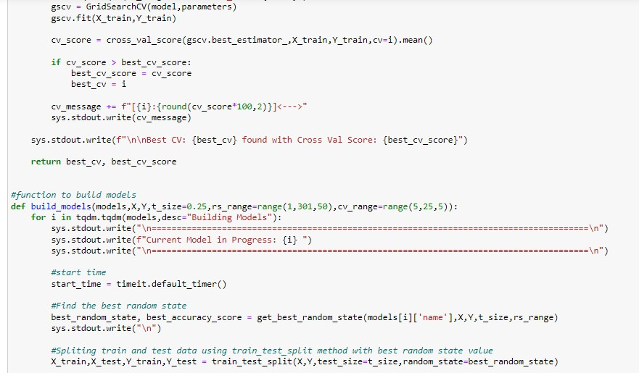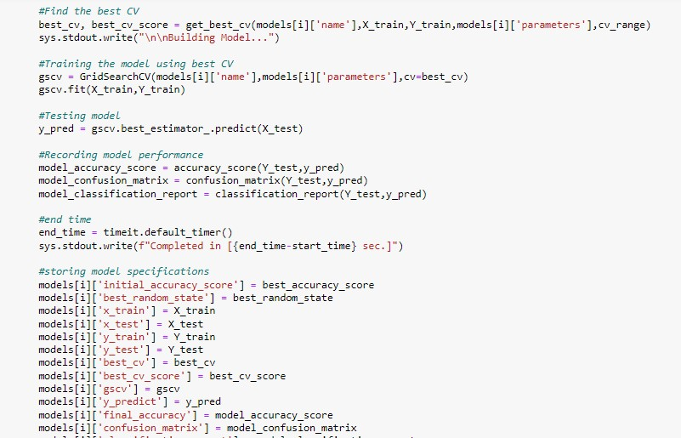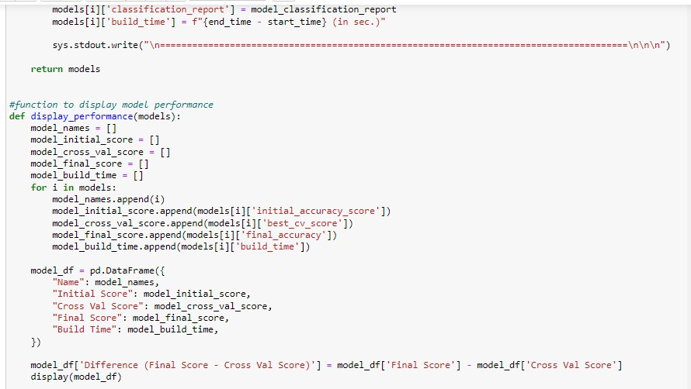

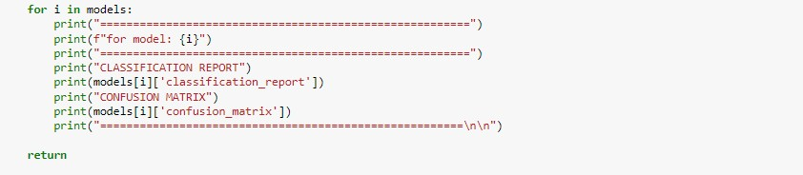

Displaying the models performance:

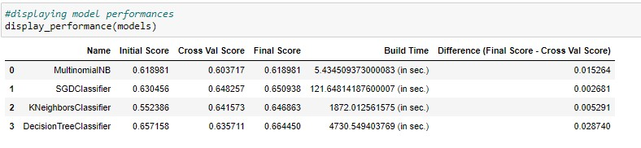

======================================================== for model: MultinomialNB

========================================================

CLASSIFICATION REPORT

precision recall f1-score support

1. 0.68 0.73 0.70 1862
2. 0.55 0.48 0.51 1845
3. 0.49 0.58 0.53 1793
4. 0.62 0.59 0.60 1958
5. 0.78 0.70 0.74 1867

accuracy 0.62 9325 macro avg 0.62 0.62 0.62 9325 weighted avg 0.62 0.62 0.62 9325

CONFUSION MATRIX

[[1366 309 149 27 11]

[ 424 894 411 85 31]

[ 158 300 1040 235 60]

[ 51 91 391 1161 264]

[ 24 33 121 378 1311]]

=======================================================

========================================================

for model: SGDClassifier

========================================================

CLASSIFICATION REPORT

precision recall f1-score support

1. 0.69 0.74 0.72 1886
2. 0.56 0.56 0.56 1843
3. 0.59 0.53 0.56 1850
4. 0.62 0.63 0.63 1843
5. 0.79 0.78 0.78 1903

accuracy 0.65 9325 macro avg 0.65 0.65 0.65 9325

weighted avg 0.65 0.65 0.65 9325

CONFUSION MATRIX

[[1401 315 111 44 15]

[ 393 1036 263 107 44]

[ 164 346 987 278 75]

[ 42 128 241 1168 264]

[ 19 37 74 295 1478]]

=======================================================

======================================================== for model: KNeighborsClassifier

========================================================

CLASSIFICATION REPORT

precision recall f1-score support

1. 0.66 0.72 0.69 1870
2. 0.68 0.55 0.61 1901
3. 0.53 0.64 0.58 1877
4. 0.67 0.56 0.61 1808
5. 0.72 0.76 0.74 1869

accuracy 0.65 9325 macro avg 0.65 0.65 0.65 9325

weighted avg 0.65 0.65 0.65 9325

CONFUSION MATRIX

[[1351 176 218 58 67]

[ 330 1050 360 92 69]

[ 198 189 1201 170 119]

[ 103 77 317 1018 293]

[ 74 50 153 180 1412]] =======================================================

======================================================== for model: DecisionTreeClassifier

========================================================

CLASSIFICATION REPORT

precision recall f1-score support

1. 0.72 0.72 0.72 1851
2. 0.61 0.61 0.61 1895
3. 0.60 0.60 0.60 1871
4. 0.64 0.66 0.65 1870
5. 0.76 0.74 0.75 1838

accuracy 0.66 9325 macro avg 0.67 0.66 0.67 9325 weighted avg 0.67 0.66 0.66 9325

CONFUSION MATRIX

[[1332 278 144 59 38]

[ 299 1156 265 130 45]

[ 141 266 1126 231 107]

[ 44 128 238 1231 229]

[ 37 76 109 265 1351]]

=======================================================

**Observation:** From the above model performance comparison, it is clear that

**SGDClassifier** performs well with **accuracy_score of 65.09%** and **lowest difference between accuracy_score and cross_val_score**. Hence, we are proceeding with **SGDClassifier** as the final model.

**Saving the best model:**

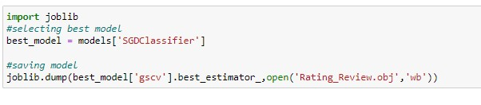

* Key Metrics for success in solving problem under consideration:

To find out best performing model, the following metrices are used:

* 1. Accuracy Score: It is used to check the model performance score between 0.0 to 1.0
  2. Confusion Matrix: A confusion matrix is a table that is often used to describe the performance of a classification model (or "classifier") on a set of test data for which the true values are known.
  3. Cross Validation: Cross-validation helps to find out the over fitting and under fitting of the model. In the cross validation the model is made to run on different subsets of the dataset which will get multiple measures of the model. If we take 5 folds, the data will be divided into 5 pieces where each part being 20% of full dataset. While running the Cross validation the 1st part (20%) of the 5 parts will be kept out as a holdout set for validation and everything else is used for training data. This way we will get the first estimate of the model quality of the dataset.

In the similar way further iterations are made for the second 20% of the dataset is held as a holdout set and remaining 4 parts are used for training data during process. This way we will get the second estimate of the model quality of the dataset. These steps are repeated during the cross-validation process to get the remaining estimate of the model quality.

* 1. Classification Report: A Classification report is used to measure the quality of predictions from a classification algorithm. How many predictions are True and how many are False.
  2. Hyperparameter Tuning: There is a list of different machine learning models. They all are different in some way or the other, but what makes them different is nothing but input parameters for the model. These input parameters are named as Hyperparameters. These hyperparameters will define the architecture of the model, and the best part about these is that you get a choice to select these for your model. You must select from a specific list of hyperparameters for a given model as it varies from model to model. We are not aware of optimal values for hyperparameters which would generate the best model output. So, what we tell the model is to explore and select the optimal model architecture automatically. This selection procedure for hyperparameter is known as Hyperparameter Tuning. We can do tuning by using GridSearchCV. GridSearchCV is a function that comes in Scikit-learn (or SK-learn) model selection package. An important point here to note is that we need to have Scikit-learn library installed on the computer. This function helps to loop through predefined hyperparameters and fit your estimator (model) on your training set. So, in the end we can select the best parameters from the listed hyperparameters.
* Visualizations:

To better understand the data, the following types of visualizations have been used.

* Univariate analysis is the simplest form of data analysis where the data being analyzed contains only one variable. In this project, distribution plot, count plot, box plot and bar plot has been used.

**Count Plot:**

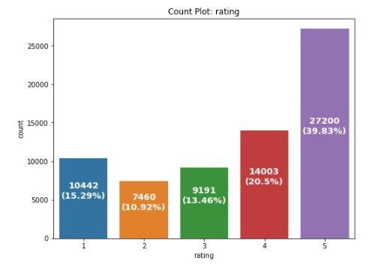

Observations:

* + In the above plot we can see how initially we had an imbalanced class concern that we later rectified by manually choosing the same number of records for each and every class and ensuring that the dataset get balanced multiclass label variable.
  + There are records available for all ratings i.e., from 1 to 5.
  + There are highest number of 5 star ratings followed by 4 star ratings present in the dataset.
  + We can see a high 1 star rating as well compared to 2 and 3 star rating reviews.

**Distribution Plot: Review text length Distribution Plot before Data Cleaning**

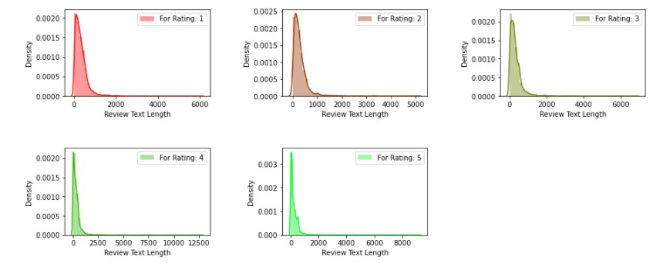

Observations:

* + Rating 1, 3, 5 has almost similar review text length.
  + Rating 4 has the highest review text length.
  + Rating 2 has the lowest review text length.

**Review text length Distribution Plot after Data Cleaning:**

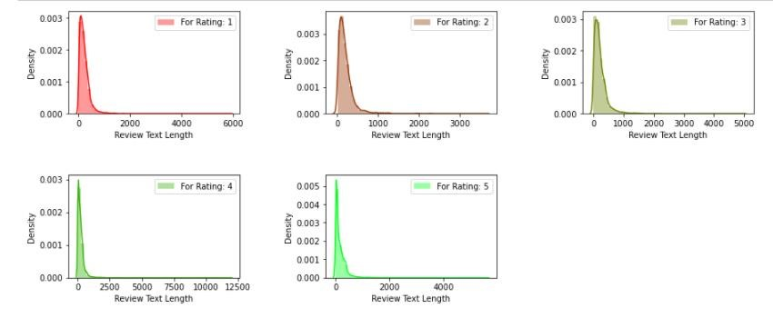

Observation: Review text length reduced by almost 1000 characters for Rating 1 to 5.

**Displaying with WordCloud:**

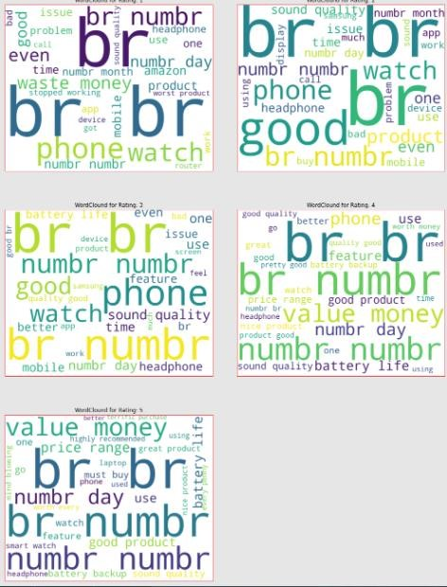

**Observations:**

* + **for Rating: 1**

It is mostly consists of words like phone, headphone, waste, money, slow, worst, issue etc.

* + **for Rating: 2**

It is mostly consists of words like phone, good, watch, product, problem, issue, bad etc.

* + **for Rating: 3**

It is mostly consists of words like phone, good, watch, problem, sound, feature, quality etc.

* + **for Rating: 4**

It is mostly consists of words like phone, good, value, money, nice product, battery backup, great etc.

* + **for Rating: 5**

It is mostly consists of words like value, money, must buy, great, perfect, better, terrific purchase, mind blowing etc.

* + Interpretation of the Results
* Starting with univariate analysis, with the help of countplot, it was found that the data consists of highest number of 5 star rating followed by 4 star ratings. Moving further with the removal and replacement of certain terms (like, punctuations, extra spaces, numbers, money symbols) as well as removal of stop words, it was evident that the length of review text decreases by a large amount. This was also depicted by using distribution plot.
* With the help of wordcloud, it was found that the rating 1 consists of words like phone, headphone, waste, money, slow, worst, issue etc, rating 2 consists of words like problem, issue, bad, etc, rating 3 consists of words like problem, sound, quality etc, rating 4 consists of word like good, value, money, nice, etc. and rating 5 consists of words like must buy, great, perfect, mind blowing etc.

## CONCLUSION

* Key Findings and Conclusions of the Study

From the model performance comparison, it is clear that SGDClassifier performs well with accuracy_score of 65.09% and lowest difference between accuracy_score and cross_val_score, hence proceeding with SGDClassifier as our final model.

* Learning Outcomes of the Study in respect of Data

Science

During the data analysis, Review_text feature contains null values which have been dropped, but these values can also be replaced with some other values which might impact the model performance either in positive or negative way. As of now, I am finishing this project with my current approach which gives the **final accuracy score of 65.09% and cross_val_score: 64.82%** and this can be further improved by training with more specific data.

* Limitations of this work and Scope for Future Work

Current model is limited to technical product rating(s) and reviews data but this can further be improved for other sectors of ecommerce rating(s) prediction by training the model accordingly. The overall score can also be improved further by training the model with more specific data.

As we know the content of text in reviews is totally depends on the reviewer and they may rate differently which is totally depends on that particular person. So it is difficult to predict ratings based on the reviews with higher accuracies. Still we can improve our accuracy by fetching more data and by doing extensive hyper-parameter tuning.